
Monday, Oct 04 2010

South African men are 'raping women to cure them of being lesbians'
By Daily Mail Reporter
Last updated at 11:08 AM on 13th March 2009
Lesbians living in South Africa are being raped by men who believe it will 'cure' them of their sexual orientation, a report has revealed.
Women are reporting a rising tide of brutal homophobic attacks and murders and the widespread use of 'corrective' rape as a form of punishment.
The report, commissioned by international NGO ActionAid, called for South Africa's criminal justice system to recognise the rapes as hate crimes as police are reportedly failing to take action over the spiralling violence.
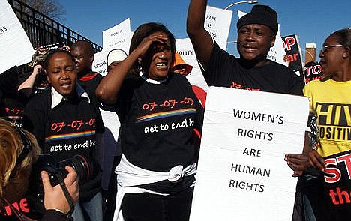
Horrific crimes against lesbians in South Africa are reportedly going unrecognised by the state and unpunished by the legal system
The extent of the brutality became clear when Eudy Simelane, former star of South Africa's national female football squad, became one of the victims last April.
Simelane, one of the first women to live openly as a lesbian and an equality rights campaigner, was gang-raped and beaten before being stabbed to death 25 times in the face, chest and legs.

Eudy Simelane died after being gang-raped, beaten and stabbed 25 times
Triangle, a gay rights organisation, said it deals with up to 10 new cases of 'corrective rape' every week.
Support groups claim an increasingly macho political environment led to inaction over attacks.
A statement released by South Africa's national prosecuting authority said: 'While hate crimes – especially of a sexual nature – are rife, it is not something that the South African government has prioritised as a specific project.'
Human rights and equality campaigners are hoping the reaction to Simelane's death and the trial of the three men accused of her rape and murder will help put an end to the attacks.
Laura Turquet, ActionAid’s women’s rights coordinator, said: 'So-called "corrective" rape is yet another grotesque manifestation of violence against women, the most widespread human rights violation in the world today.
'These crimes continue unabated and with impunity, while governments simply turn a blind eye.'

